## Objective

You will create a unique work of digital art by drawing randomly colored circles of varied widths at random locations of the screen.

## Topics: methods, parameters, color, random

# Instructions

Use the **ellipse()** method, plus any other relevant methods we have already discussed in class, to create a randomly generated work of digital art.

# Examples

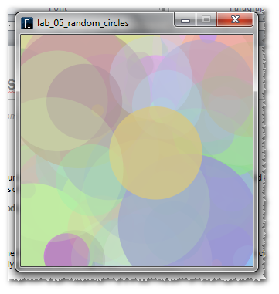

# Hints

Using different alpha values for each circle creates more pleasing interesctions.

# Challenge

Add the **noLoop()** command to your **setup()** method. This causes **draw()** to only execute once. Instead of randomly generating circles forever, use a for or while loop to generate a fixed number of circles.